The governing equation for this problem:

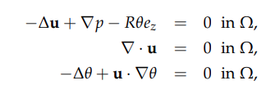

The boundary conditions are:

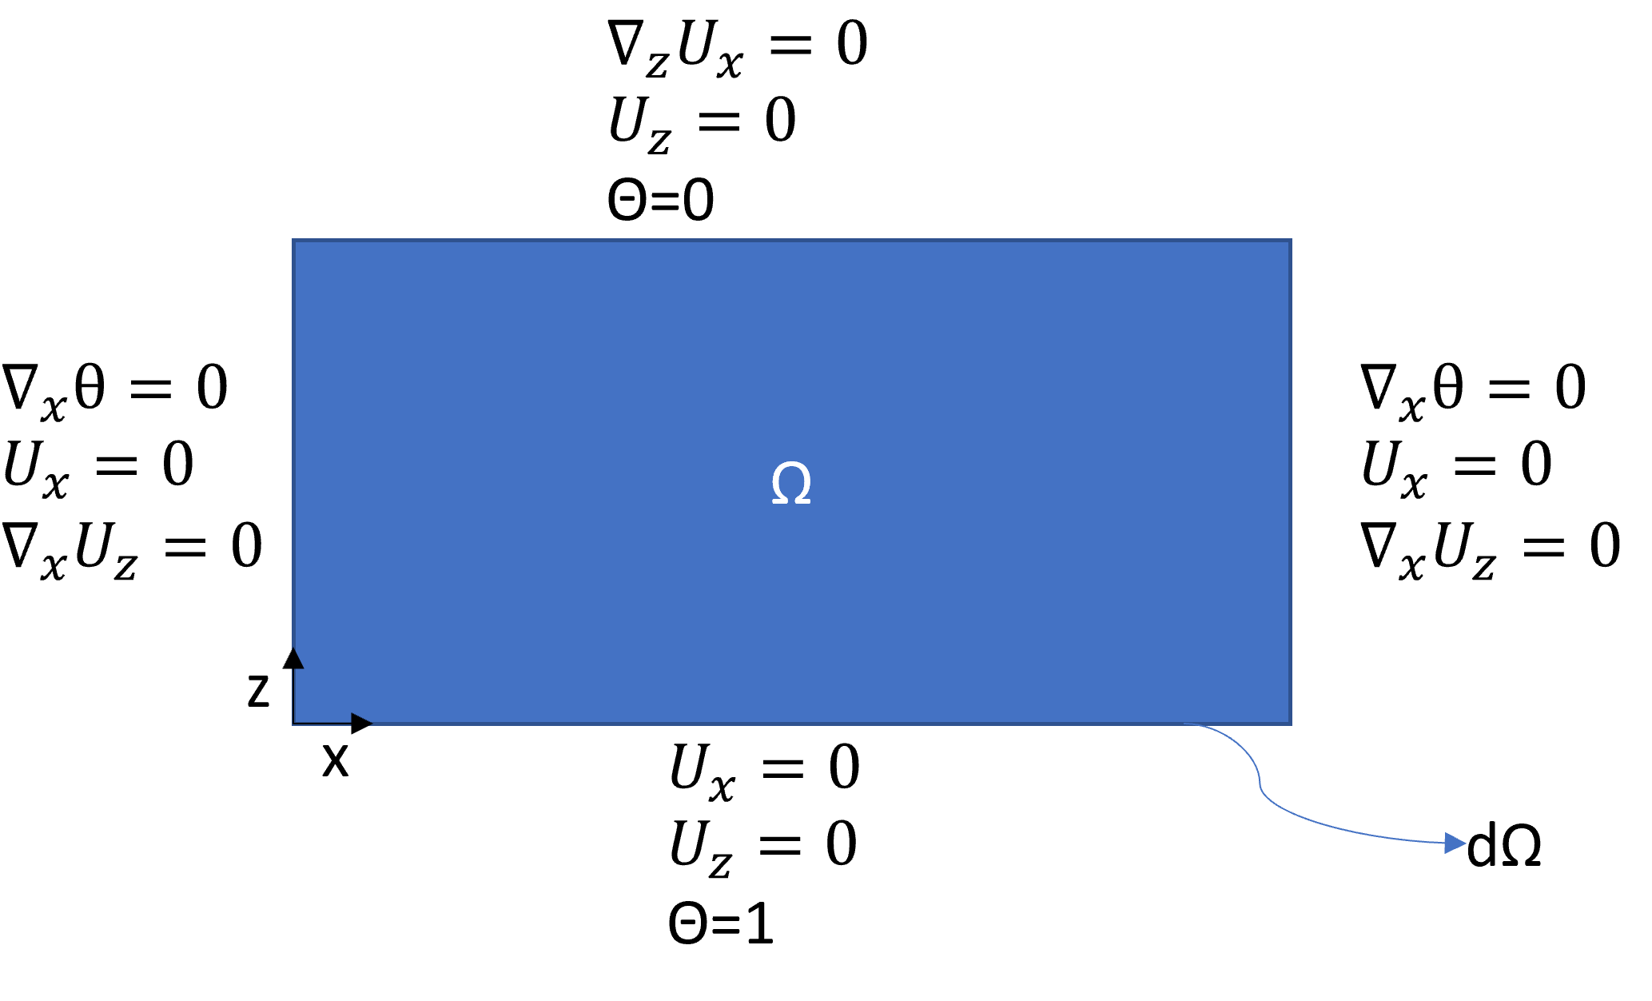

The code uses the central difference scheme with 1st order accuracy to solve. The solution for an aspect ratio of 3.495 and Rayleigh number, R, of 1300:

